**Sybase ASE Database and log backup and Azure Blob movement**

Contents

1 Purpose 2

1.1 Audience 3

1.2 Assumptions 3

2 Prerequisites for installation 3

3 Storage account and Azcopy 4

5 Servers in Scope 5

6 Sybase Data and log backup Schedule: 7

7 Backup and Azcopy blob movement script: 10

7.1 ASE DB backup and Azcopy blob movement: 10

8 Cronjob schedule 13

9 Blob Lifecyle 14

10 Version History 18

# 

# 1 Purpose

The purpose of this document is to automate the SAP Sybase ASE database to perform timely backup of both Data and Logs and move it to Azure blob containers with retention at local server. Database compression is also achieved via shell script and this document will outline these procedures that are followed for the Development, QA and Production servers within BHF SAP subscription.

## Audience

This document is for the Infrastructure-specific architectural design as it relates to the SAP infrastructure on Azure Cloud. The target audience is intended to be Azure Technologists, BASIS Administrators and SAP Technical Architects.

## Assumptions

The following assumptions have been made and the implementation of the Sybase data and log backup has been taking these into consideration:

* Any items that are not explicitly mentioned In-Scope are considered Out of Scope.

The backup script can be used only for Single instance of Sybase DB running within a VM (Single SID)

# Prerequisites for installation

|  |  |  |  |
| --- | --- | --- | --- |
| Parameter Name | Default Value | Required | Description |
| ASE SysAdmin Password | password | required | Password for the Sybase ASE user specified in the ASE SysAdmin Username parameter. |
| ASE SysAdmin Username | sasap | required | The Sybase ASE user who can perform all administrative operations (typically sa).  This user will perform the database load operation. |
| Cache Dump File | no default | optional | Database cache file associated with this database dump. This is a single filename (with absolute path—the path and file must exist). The file contains detailed information about any specific (non-default) data caches used by the source database and any database objects bound to those caches. |
| Database Instance Name | NY_DS | required | The name of the Sybase ASE instance where the database will be loaded from the dump file (or files). |
| Storage Account | N/A | required | For data movement using Azcopy, a storage account is necessary. Details of which are found in the subsequent sections. |
| Azcopy | n/a | required | Install Az copy |

# [Storage](https://docs.microsoft.com/en-us/azure/azure-netapp-files/azacsnap-installation#enable-communication-with-sap-hana) account and Azcopy

* Create azure blob storage for taking the backup below is the link to follow  
   <https://docs.microsoft.com/en-us/azure/storage/common/storage-account-create?tabs=azure-portal>
* Generate SAS tokens for your storage containers <https://docs.microsoft.com/en-us/azure/cognitive-services/translator/document-translation/create-sas-tokens?tabs=Containers>

BHF SAP subscription has the following storage accounts created for data and log blob movement.

|  |  |  |
| --- | --- | --- |
| S.No | Environment | Storage account |
| 1 | Development | sapstordbbackupsuse2dv |
| 2 | Quality | Sapstordbbackupcusqa |
| 3 | Production | sapstordbbackupuse2pr |



* AzCopy sync is a command-line utility that can be used to sync blobs or files from local machines to Azure blobs and vice versa. A documentation on Azcopy is here for further reading. SAP Sybase ASE Database servers are all installed with Azcopy within the BHF SAP subscripton. The list of Sybase DB servers are mentioned in the below sections.  
  <https://docs.microsoft.com/en-us/azure/storage/common/storage-use-azcopy-v10>

# 5 Servers in Scope

The list of servers and the individual blob containers are mentioned in separate tables as below.

|  |  |  |  |
| --- | --- | --- | --- |
| **Component** | **Azure VM Name** | **VM Primary IP** | **Env** |
|  |
| SAP BusinessObjects Business Intelligence platform (Bobj) (ASE DB ) | biddb01use2dv | 10.213.38.14 | Development |  |
| Fiori for S/4HANA On-Premise Edition (ASE DB ) | fd2db01use2dv | 10.213.38.22 | Development |  |
| Sybase Power Designer (ASE DB ) | dpddb01use2dv | 10.213.38.28 | Development |  |
| SAP BusinessObjects Business Intelligence platform (Bobj) | biqdb01cusqa | 10.214.26.7 | Quality |  |
| Fiori for S/4HANA On-Premise Edition | fq2db01cusqa | 10.214.26.25 | Quality |  |
| SAP BusinessObjects Business Intelligence platform (Bobj) (ASE DB ) | bipdb01use2pr | 10.213.32.139 | Production |  |
| SAP BusinessObjects Business Intelligence platform (Bobj) (ASE DB ) | bipdb02use2pr | 10.213.32.141 | Production |  |
| Fiori for S/4HANA On-Premise Edition (ASE DB ) | fipdb01use2pr | 10.213.32.155 | Production |  |
| Fiori for S/4HANA On-Premise Edition (ASE DB ) | fipdb02use2pr | 10.213.32.157 | Production |  |
| SAP BusinessObjects Business Intelligence platform (Bobj) (ASE DB ) | bipdb01cusdr | 10.214.26.64 | DR |  |
| Fiori for S/4HANA On-Premise Edition (ASE DB ) | fipdb01cusdr | 10.214.26.70 | DR |  |

|  |  |  |  |
| --- | --- | --- | --- |
| **Sybase VMs** | **Local path** | **Blob Container** | **Path** |
| biddb01use2dv | /backup/ DATA | https://sapstordbbackupsuse2dv.blob.core.windows.net/bid | /SID/data |
| /backup/log | /SID/log |
| fd2db01use2dv | /backup/ DATA | https://sapstordbbackupsuse2dv.blob.core.windows.net/fd2 | /SID/data |
| /backup/log | /SID/log |
| dpddb01use2dv | /backup/ DATA /backup/log | https://sapstordbbackupsuse2dv.blob.core.windows.net/dpd/ | /SID/dpddb01/data/SID/dpddb01/log/ |
| biqdb01cusqa | /backup/ DATA | https://sapstordbbackupcusqa.blob.core.windows.net/biq | /SID/backup-new/ |
| /backup/log | /SID/backup-newlog/ |
| fq2db01cusqa | /backup/ DATA | https://sapstordbbackupcusqa.blob.core.windows.net/fq2 | /SID/backup-new/ |
| /backup/log | /SID/backup-newlog/ |
| bipdb01use2pr | /backup/ DATA | https://sapstordbbackupuse2pr.blob.core.windows.net/bip | /SID/bipdb01/data |
| /SID/bipdb02/data |
| bipdb02use2pr | /backup/log | /SID/bipdb01/log |
| /SID/bipdb02/log |
| fipdb01use2pr | /backup/ DATA | https://sapstordbbackupuse2pr.blob.core.windows.net/fip | /SID/fipdb01/data |
| /SID/fipdb02/data |
| fipdb02use2pr | /backup/log | /SID/fipdb01/log |
| /SID/fipdb02/log |
| bipdb01cusdr | /backup/ DATA | https://sapstordbbackupcusqa.blob.core.windows.net/dr-bip | /SID/bipdrdb/data |
| bipdb02cusdr | /backup/log | /SID/bipdrdb/log |
| fipdb01cusdr | /backup/ DATA | https://sapstordbbackupcusqa.blob.core.windows.net/dr-fip | /SID/fipdrdb/data |
| fipdb02cusdr | /backup/log | /SID/fipdrdb/log |

# 6 Sybase Data and log backup Schedule:

The Sybase DB backup is scheduled through cronjobs in the OS level. The schedule is as below.

Non-Prod:

* Data:- Ever 1st, 3rd and 5th day of the week at 20:30 UTC, scheduled script will execute the backup with 101 compression and upon successful execution, the backed up data and log will be transported to Azure blob using Azcopy. Local backup retention is set as 10080 minutes. (7days)
* Log:- Every 15 mins, scheduled script will execute the log backup and upon successful execution, the backed up data and log will be transported to Azure blob using Azcopy. Local backup retention is set as 1440 mins (1 day)

Prod:

* Data:- Everyday of the week at 20:30 UTC, scheduled script will execute the backup with 101 compression and upon successful execution, the backed up data and log will be transported to Azure blob using Azcopy. Local backup retention is set as 10080 minutes. (7days)
* Log:- Every 15 mins, scheduled script will execute the log backup and upon successful execution, the backed up data and log will be transported to Azure blob using Azcopy. Local backup retention is set as 1440 mins (1 day)

|  |  |  |  |  |  |  |
| --- | --- | --- | --- | --- | --- | --- |
| Environment | Backup | Type | Tool | Backup Policy | Retention period | |
| Local Disk in days | Blob in days |
| Non Prod (DEV)  BID(CMS) | DB dump | Sybase all DBs Backup | Shell Script | MON, WED, FRI - 9 PM UTC | 7 | 30 |
| Log Files | Sybase all log files Backup | Shell Script | every 10 minutes | 2 | 30 |
| DB dump | DB to Blob Movement | Azcopy | MON, WED, FRI - 9 PM UTC | 7 | 30 |
| Log Files | Log files to Blob Movement | Azcopy | every 10 minutes | 2 | 30 |
| Log Cleanup | Log files cleanup | find mytype to del | every 10 minutes | 2 |  |
|  | | | | | | |
| Non Prod (DEV)  BID(AUDIT) | DB dump | Sybase all DBs Backup | Shell Script | MON, WED, FRI - 8:30 PM UTC | 7 | 30 |
| Log Files | Sybase all log files Backup | Shell Script | every 15 minutes | 2 | 30 |
| DB dump | DB to Blob Movement | Azcopy | MON, WED, FRI - 8:30 PM UTC | 7 | 30 |
| Log Files | Log files to Blob Movement | Azcopy | every 15 minutes | 2 | 30 |
| Log Cleanup | Log files cleanup | find mytype to del | every 15 minutes | 2 |  |
|  |  |  |  |  |  |  |
| Non Prod (DEV)  DPD | DB dump | Sybase all DBs Backup | Shell Script | MON, WED, FRI - 8:30 PM UTC | 7 | 30 |
| Log Files | Sybase all log files Backup | Shell Script | every 15 minutes | 7 | 30 |
| DB dump | DB to Blob Movement | Azcopy | MON, WED, FRI- 11 PM UTC | 7 | 30 |
| Log Files | Log files to Blob Movement | Azcopy | every 20 minutes | 7 | 30 |
| Log Cleanup | Log files cleanup | find mytype to del | every 20 minutes | 7 |  |
|  |  |  |  |  |  |  |
| Non Prod (DEV)  FD2 | DB dump | Sybase all DBs Backup | Shell Script | MON, WED, FRI - 8:30 PM UTC | 7 | 30 |
| Log Files | Sybase all log files Backup | Shell Script | every 15 minutes | 2 | 30 |
| DB dump | DB to Blob Movement | Azcopy | MON, WED, FRI - 8:30 PM UTC | 7 | 30 |
| Log Files | Log files to Blob Movement | Azcopy | every 15 minutes | 2 | 30 |
| Log Cleanup | Log files cleanup | find mytype to del | every 15 minutes | 2 |  |
|  | | | | | | |
| Non Prod (QA) | DB dump | Sybase all DBs Backup | Shell Script | MON, WED, FRI - 8:30 PM UTC | 7 | 30 |
| Log Files | Sybase all log files Backup | Shell Script | every 15 minutes | 7 | 30 |
| DB dump | DB to Blob Movement | Azcopy | MON, WED, FRI- 11 PM UTC | 7 | 30 |
| Log Files | Log files to Blob Movement | Azcopy | every 20 minutes | 7 | 30 |
| Log Cleanup | Log files cleanup | find mytype to del | every 20 minutes | 7 |  |
|  | | | | | | |
| Prod | DB dump | Sybase all DBs Backup | Shell Script | Everyday @ 8:30 PM UTC | 7 | 30 |
| Log Files | Sybase all log files Backup | Shell Script | every 15 minutes | 7 | 30 |
| DB dump | DB to Blob Movement | Azcopy | Everyday @ 11 PM UTC | 7 | 30 |
| Log Files | Log files to Blob Movement | Azcopy | every 20 minutes | 7 | 30 |
| Log Cleanup | Log files cleanup | find mytype to del | every 20 minutes | 7 |  |
|  | | | | | | |
| DR | DB dump | Sybase all DBs Backup | Shell Script | Everyday @ 8:30 PM UTC | 7 | 30 |
| Log Files | Sybase all log files Backup | Shell Script | every 15 minutes | 7 | 30 |
| DB dump | DB to Blob Movement | Azcopy | Everyday @ 11 PM UTC | 7 | 30 |
| Log Files | Log files to Blob Movement | Azcopy | every 20 minutes | 7 | 30 |
| Log Cleanup | Log files cleanup | find mytype to del | every 20 minutes | 7 |  |

# 7 Backup and Azcopy blob movement script:

## 7.1 ASE DB backup and Azcopy blob movement:

Please find the scripts in the below URL

<https://ts.accenture.com/:f:/r/sites/Brighthouse-SAPonCloudMigrationDelivery/Shared%20Documents/General/10%20IC%20Build/Scripts/Sybase-Backup?csf=1&web=1&e=LjLXDn>

# 8 Cronjob schedule

The below cronjob is a template where “sid” and “SID” should be replaced by the respective server identifier.

* crontab -l

Note:- (SID should be replace as per the sid and it should case sensitive)

For example, FQ2 server from Development is taken as a reference below. The above cronjob is adapted for FQ2 as below. This script is executed by the user sybfq2 and the cronjob is set on the sudo/root user. Similar approach to be used for upcoming new Sybase DB builds.

#database dump  for every 3 days for sybase server

30 20 * * 1,3,5 su sybfq2 -c "sh /backup/FQ2backup.sh"

#database dump copy to blob script for every 3 days form sybase server && delete local dump copy after retention period

00 23 * * 1,3,5 sh /backup/FQ2azcopy.sh

#log dump  for every 15 mins for sybase server

*/15 * * * * su sybfq2 -c "sh /backup/FQ2trans_log.sh"

#log dump copy to blob script for every 20 mins form sybase server && delete local dump copy after retention period

*/20 * * * * sh /backup/FQ2azcopylog.sh

DR crontab.

#database dump for every day for sybase server  
30 20 * * 1,3,5 su - sybfip -c "sh /backup/FIPbackup.sh > /backup/FIPdatabaselog.txt"

#database dump copy to blob script for every 3 days form sybase server && delete local dump copy after retention period  
00 23 * * 1,3,5 sh /backup/FIPazcopy.sh

#log dump for every 15 mins for sybase server  
*/15 * * * * su - sybfip -c "sh /backup/FIPlog.sh > /backup/FIPtranslog.txt"  
#log dump copy to blob script for every 20 mins form sybase server && delete local dump copy after retention period  
*/20 * * * * sh /backup/FIPazcopylog.sh

# 9 Blob Lifecyle

The Blob retention is 30days for both Data and Log. From the storage account, navigate to Lifecycle Management of the containers and choose FQ2 and set the retention policies as shown below.

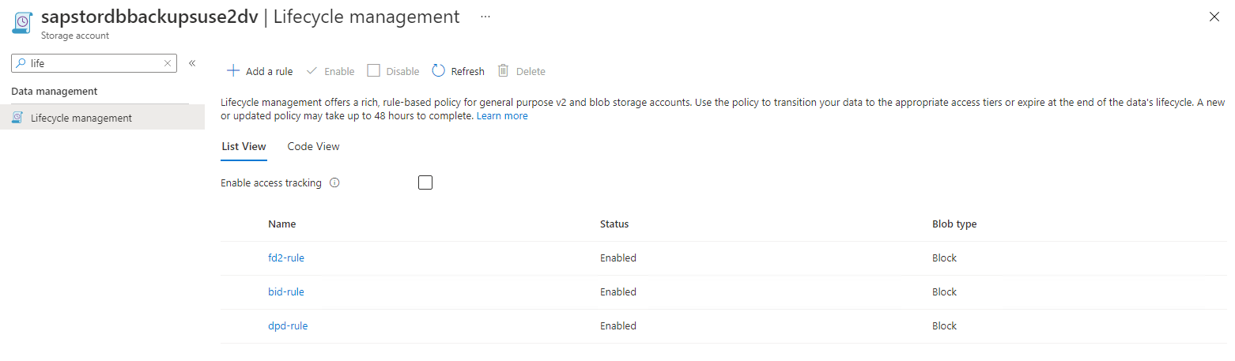

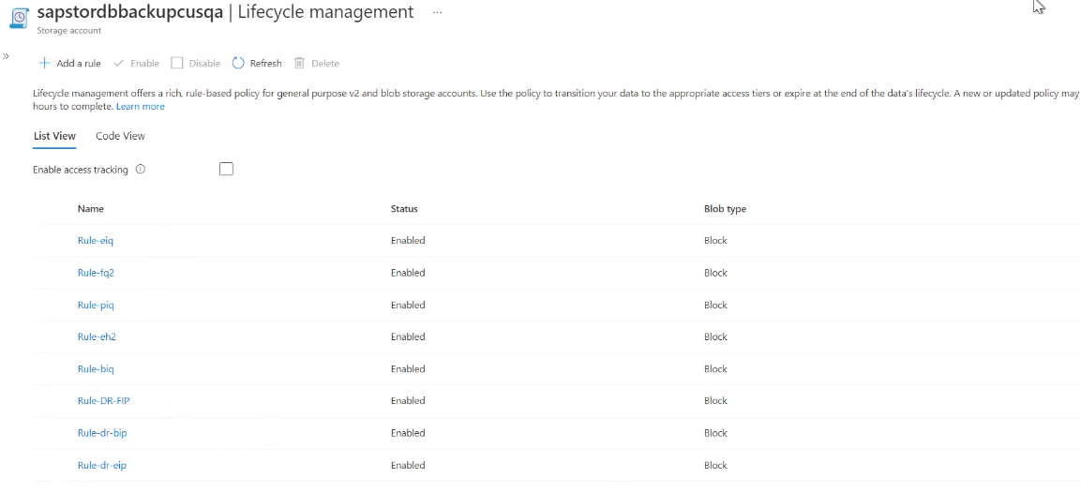

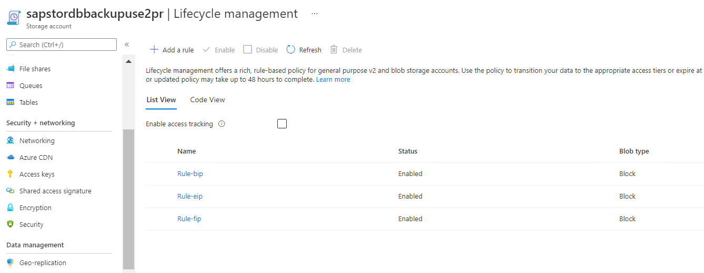

# 10 Version History

|  |  |  |  |
| --- | --- | --- | --- |
| Version | Date | Created / Reviewed by | Remarks |
| 1.0 | 12/8/2021 | Sunil Ramachandra/senthil.vel.murugan | Initial version created |
| 1.0 | 9/3/2022 | Sasikumar Sampath | Reviewed by |
| 1.0 |  |  |  |